Lab 2 (2%)

Uncorrelated subqueries

topics

uncorrelated queries

Group work acknowledgment

We members of Group 2 **[Kabir Narula] [Maksym Volkovynskyi**] declare that the attached assignment is our own work in accordance with the Seneca Academic Policy. No part of this assignment has been copied manually or electronically from any other source (including web sites) **or distributed to other students.**

**Specify below what each member has done towards the completion of this work:**

|  |  |  |
| --- | --- | --- |
|  | **Name** | **Task(s)** |
| **1-** | **Kabir Narula** | **Everything** |
| **2-** | **Maksym Volkovynskyi** | **Everything** |

**We did each question individually so that we can practice better and then later compared and matched our answers…**

Before you start

You are to create a new database named “AviaCo” and run the sql script you are given to create the tables in the database.

Instructions

For each of the following questions write the sql query (in text) and show the result set underneath each SQL query.

1. What is the maximum charter fuel consumption per hour. Fuel consumption per hour is calculated as follows: fuelPerHr= CHAR_FUEL_GALLONS/ CHAR_HOURS_FLOWN.

Output:



**[Answer] ----------**

select max(sub.consumption) as 'max fuel consumption per hour'

from (

select c.CHAR_FUEL_GALLONS / c.CHAR_HOURS_FLOWN as consumption

from CHARTER c

) sub;

**[Output] ----------**

1. Show the charters that have the highest fuel consumption per hour.

Fuel consumption per hour is calculated as follows:

fuelPerHr= CHAR_FUEL_GALLONS/ CHAR_HOURS_FLOWN.

-- use query 1 as subquery in a where clause.

Output:

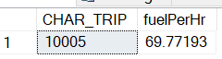

**[Answer] ----------**

select c.CHAR_TRIP, c.CHAR_FUEL_GALLONS / c.CHAR_HOURS_FLOWN as fuelPerHr

from CHARTER c

where c.CHAR_FUEL_GALLONS / c.CHAR_HOURS_FLOWN = (

select max(sub.consumption) from (

select c2.CHAR_FUEL_GALLONS / c2.CHAR_HOURS_FLOWN as consumption

from CHARTER c2

) sub

)

**[Output] ----------**

1. Z-score transformation is a numerical transformation of a distribution/series of values that puts the values in a scale of [-3 3].

Show the charter trip and the fuel consumption per hour and the standardized fuel consumption per hour or Z-score. Fuel consumption per hour is calculated as follows:

fuelPerHr= CHAR_FUEL_GALLONS/ CHAR_HOURS_FLOWN.

the standardized fuel consumption per hour or z-score is calculated as follows.

Z-score = (fuelPerHr - avg(fuelPerHr))/stdev(fuelPerHr).

Output: first 5 rows out of 18

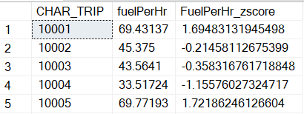

**[Answer] ----------**

select top 5 c.CHAR_TRIP, c.CHAR_FUEL_GALLONS / c.CHAR_HOURS_FLOWN as fuelPerHr,

(c.CHAR_FUEL_GALLONS / c.CHAR_HOURS_FLOWN - (select avg(c2.CHAR_FUEL_GALLONS/c2.CHAR_HOURS_FLOWN) from CHARTER c2)) / (select STDEV(c3.CHAR_FUEL_GALLONS/c3.CHAR_HOURS_FLOWN) from CHARTER c3) as FuelPerHr_zscore

from CHARTER c

**[Output] ----------**

1. Find the charters that exhibit outliers in fuel consumption per hour. Check for standardized fuel consumption per hour larger than 1.5 or less than -1.5.

-- use query3 in a “from” clause.

Output:

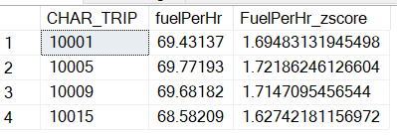

**[Answer] ----------**

select *

from (

select c.CHAR_TRIP, c.CHAR_FUEL_GALLONS / c.CHAR_HOURS_FLOWN as fuelPerHr,

(c.CHAR_FUEL_GALLONS / c.CHAR_HOURS_FLOWN - (select avg(c2.CHAR_FUEL_GALLONS/c2.CHAR_HOURS_FLOWN) from CHARTER c2)) / (select STDEV(c3.CHAR_FUEL_GALLONS/c3.CHAR_HOURS_FLOWN) from CHARTER c3) as FuelPerHr_zscore

from CHARTER c

) src

where src.FuelPerHr_zscore > 1.5 or src.FuelPerHr_zscore < -1.5

**[Output] ----------**

1. Calculate the average hourly fuel consumption per each charter destination and show only the charter destinations that have average hourly fuel consumption greater than 40.

Show also the number of charters per destination.

The hourly fuel consumption per hour is calculated as CHAR_FUEL_Gallons/CHAR_HOURS_FLOWN

Output:

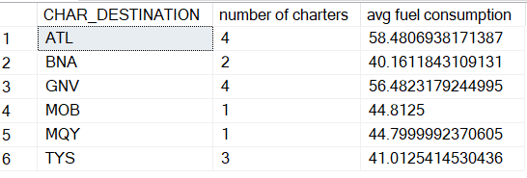

**[Answer] ----------**

select c.CHAR_DESTINATION, count(*) as 'number of charters', (

select avg(sub.fuelPerHr)

from (

select c2.CHAR_FUEL_GALLONS / c2.CHAR_HOURS_FLOWN as fuelPerHr

from CHARTER c2

where c2.CHAR_DESTINATION = c.CHAR_DESTINATION

) sub

) as 'avg fuel consumption'

from CHARTER c

group by c.CHAR_DESTINATION

**[Output] ----------**

SUBMISSION

Submit your lab2_GroupX.doc file on BB. Replace X with your group number.

If a student does not contribute to the work, do not list his/her name(s) under the group section in the lab file and will get 0.

Grading rubrics

Each question is worth 5pts. Total is 25 pts. If the output is included without the query, the answer is worth 0.